Methane emissions derived from tourism-related solid waste disposal in Cuba. A case study

Emisiones de metano derivadas de la disposición de desechos sólidos del turismo en Cuba. Estudio de caso

Abstract: This paper provides the results of a case study performed to estimate methane (CH₄) emissions arising from landfilling of solid wastes produced by domestic tourism (DTSW), and inbound tourism (ITSW) in accommodation facilities (AF) and non-hotel services facilities (NHSF) in Cuba over the period 1985 to 2011. It also examines potential underestimation, or overestimation of these emissions in the national greenhouse gas emissions inventory (NGHGI) depending on the method used to calculate the generation of municipal solid waste (MSW) and the inclusion or not of ITSW in this. Methane emissions were estimated using the IPCC 2006 Waste Model. In 2011 emissions amounted to, 1.87 Gg CH₄ yr⁻¹ (21.4% from domestic tourism and 78.6% from inbound tourism). Seventy-two per cent of these emissions were attributable to AF and 28% to NHSF. Both domestic and inbound tourism per-capita CH₄ emissions in 2011 from solid waste disposal resulted higher than per-capita emissions derived from MSW disposal from urban local residents in that year.

Keywords: Tourism, accommodation facilities, solid waste, methane emissions, greenhouse gas inventories

RESUMEN: Este artículo, proporciona los resultados de un estudio de caso realizado para estimar las emisiones de metano (CH₄) provenientes de la disposición de desechos sólidos producidos por el turismo doméstico (DTSW) e internacional (ITSW) en instalaciones de alojamiento (AF) y de servicios extra-hoteleros (NHSF) en Cuba en el período 1985 a 2011. También examina la subestimación o sobrestimación potencial de esas emisiones en el inventario nacional de gases de invernadero (NGHGI) en dependencia del método utilizado para calcular la generación de desechos sólidos municipales (MSW) y la inclusión, o no, de ITSW en ese cálculo. Las emisiones de CH₄ fueron estimadas utilizando el Modelo de Desechos del IPCC 2006. En 2011 las emisiones resultaron 1.87 Gg CH₄ año⁻¹ (21.4% derivadas del turismo doméstico y 78.6% del turismo internacional). Setenta y dos por ciento de esas emisiones fueron atribuibles a AF y 28% a NHSF. Las emisiones per-cápita de CH₄, tanto del turismo doméstico como internacional, resultaron más altas que las emisiones per-cápita derivadas de la disposición de MSW de los residentes locales urbanos en ese año.

Palabras Claves: Turismo, instalaciones de alojamiento, desechos sólidos, emisiones de metano, inventarios de gases de invernadero
Introduction
The tourism industry has an important contribution to global greenhouse gas (GHG) emissions that has been assessed and divulged in different reports (e.g., UNWTO-UNEP-WMO, 2008). However unlike the global assessments, the estimation and reporting of GHG emissions from this industry at national level has received smaller attention and mainly focused in carbon dioxide (CO₂) emissions from the energy sector. According to the report mentioned above, emissions from tourism, including transports, accommodation and other activities accounted for about 5% of global carbon dioxide (CO₂) emissions in 2005. Transport generated 75% of these emissions and accommodation 21%. That contribution may be higher (from 5% to 14%) taking into account, the radiative forcing caused by CO₂ as well as other GHG. As this calculation only includes energy throughput, it needs to be understood as conservative (Simpson et al., 2008).

Additionally to the global assessments, ‘perspectives from smaller scales (national, sub national) must be appreciated, because it is on scales down to the local level that response measures will be implemented’ (Cusman & Jones, 2002). To achieve a better understanding of GHG emissions from tourist activities at national level, additionally to the energy sector, attention should also be paid to other sectors and categories of the national GHG inventory (NGHGI) and other direct GHG that, despite their smallest contribution to the emissions in comparison to CO₂ from fuel combustion includes GHG with high Global Warming Potential. Emissions of non-CO₂ direct GHG could have certain importance for the emissions from the tourism sector expressed in CO₂ equivalents, e.g. methane (CH₄) derived from solid waste disposal in solid waste disposal sites (SWDS).

To estimate GHG emissions arising from tourism at national scale some barriers exist, including that ‘tourism is not a traditional sector in the System of National Accounts’ (Becken & Patterson, 2006), and also is not a separate category under the Common Reporting Framework of the Intergovernmental Panel on Climate Change (IPCC) Guidelines for NGHGI.

This paper explores, with a focus on the NGHGI of developing countries and, in particular, Cuba, the issues in estimating at national scale CH₄ emissions derived from domestic and inbound tourism solid waste landfilling. The inbound tourism, ‘comprise the activities of a non-resident visitor in the country of reference on an inbound tourism trip’ (UNWTO, 2008) and, in this paper, domestic tourism ‘comprise the activities of a resident visitor within the country of reference as part of a domestic tourism trip’. Domestic tourism solid waste (DTSW) and Inbound tourism solid waste (ITSW) were defined for this study respectively as, ‘solid wastes generated by the domestic and inbound tourism in accommodation facilities (AF) and non-hotel services facilities (NHSF) (stores, bars, cafeterias, restaurants, recreational and night centres).

Background

Literature review

In recent years several studies have reported solid waste generation and composition data for the accommodation sector in developing countries (e.g. Tang, 2004; Phuong Chi, 2005; Trung & Kumar, 2005; Kuo & Chen, 2009; Shamshiry et al., 2011; Singh et al., 2013). For the Caribbean region, detailed data were reported in USAID (1999), Gutiérrez Palacios (2002), and SEMARNAT (2004). Data provided in the literature reviewed largely correspond to solid wastes generated in guest rooms and there are few studies addressing wastes generated by tourists in activities performed in NHSF.

A number of studies have indicated that tourists and visitants results in more solid waste generation than local people (e.g. Brown et al., 1997; Ahmad & Bhat, 2008; Kuo & Chen 2009; Shamshiry et al., 2011). In the Caribbean region total per-capita rate of waste generation is about 0.8 kg day⁻¹, though it can exceed 2.4 kg day⁻¹ during peak tourism seasons in some municipalities (Hoornweg & Giannelli, 2007). In Hawaii, Konan and Chan (2010) reported that ‘on a per person per annum basis, GHG emission rates generated by visitor demand are estimated to be higher than that of residents by a factor of 4.3 for carbon, 3.2 for methane, and 4.8 for nitrous oxide’.

In the NGHGI to estimate municipal solid waste (MSW) generation and CH₄ emissions associated to its disposal, ‘most developing countries use default data for per-capita generation with inter-annual changes assumed to be proportional to total or urban population’ (Bogner et al., 2009). Hockett et al. (1995) recognizes several defects to available models for per-capita solid waste generation, ‘because often they are only centred in demographic variables and therefore they measure, mainly, the residential sources of waste in spite of other important sources as commercial and institutional’. Those authors also highlight that ‘the analyses based on residential variables neither reflect the contributions from tourists to the solid waste stream’.

Objectives of the study

This study investigates issues related to the estimation of CH₄ emissions derived from DTSW and ITSW landfilled at national scale in Cuba. The main objectives are: a) to estimate the annual amounts of DTSW and ITSW produced in AF and NHSF and landfilled in the period from 1985 to 2011, b) to estimate the annual CH₄ emissions associated to DTSW and ITSW landfilled from 1985 to 2011, c) to discuss the potential underestimation or overestimation of CH₄ emissions arising from MSW landfilling in relation to the method applied in the NGHGI to estimate the MSW generated and disposed and the inclusion or not, in these estimates, of ITSW. To investigate these issues this paper presents a case study using data gathered from the tourism sector in Cuba between 1985 and 2011. The study covered all the AF operating annually in Cuba within that period.

Location of the study

Cuba (official name Republic of Cuba) is located in the Caribbean basin at the confluence with the Gulf of Mexico and the Atlantic Ocean, between latitudes 19° and 24°N, and longitudes 74° and 85°W. The capital city is Havana. The country is an archipelago that comprises the main island Cuba, the Isla de la Juventud, and around 1600 smaller islands and keys. Has an area of 110 860 km² and its population was 11 247 925 in 2011 (75% urban). Cuba’s climate is tropical, seasonally wet, with marine influence and semi-continental features. Temperatures are generally high. Cuba’s tourist industry shows a notable growth in the last years and currently plays a substantial economic and social role in the Country. Most of its entities are organized under the Ministry of Tourism and the remaining ones are associated to this organization.

Methods and Data

Solid waste generation and disposal

Annuals amounts of DTSW and ITSW generated in AF from 1985 to 2011 were calculated using per-capita solid waste generation rates (kg guest⁻¹ day⁻¹) by type of AF (Table 1) selected from data obtained in Cuba (Palacios et al., 2002; Joa & Falcon, 2008; Terry, 2012), multiplied by the figures of annual overnight stays of domestic and inbound tourists by types of AF in Cuba from 1985 to 2011 obtained from ONEI (2012) (Figure 1). Due to the lack of data for all AF and years assessed, per-capita solid waste generation rates were assumed constant for the whole period. To obtain minimal and maximal indicative values for each type of AF assessed and estimate uncertainties of this activity data, additionally, these per-capita solid waste generation rates obtained from AF of Cuba were supplemented with data from the literature from developing countries mentioned above, especially the reports for the tourist destinations of Mexico (Gutierrez Palacios, 2002) and Dominican Republic (SEMARNAT 2004) whose characteristics are similar to the Cuban tourist destinations.

Due to the lack of sufficient measured data, solid wastes generated by inbound and domestic tourists in NHSF were calculated from the solid wastes generated in AF and estimates of the proportion of solid waste generation occurring at the AF as compared to NHSF (Table 1). In selecting the proportions, information on the AF’s category and the regime and services offered, was used alongside the non-hotel services characteristics of the particular tourist destination the AF was located. Values reported by Joa & Falcon (2008) on the percentages of solid wastes generated by tourists in hotels and the NHSF, in several tourist destinations of Cuba, informed the choices made. For example, considering Table 1, a 5 star Hotel located in a tourist destination with significant NHSF would expect to generate 50% of the total guest wastes whereas a 5 star Hotel located in a tourist destination with few NHSF would generate 90%.

DTSW and ITSW disposed in SWDS was estimated from the DTSW and ITSW generated annually by waste components and the quantities of these components recycled annually. Changes in waste management practices were determined for the period assessed using the characteristics and evolution of SWDS in each tourist destination, the DTSW and ITSW proportion disposed annually in each type of SWDS, and mostly IPCC default methane corrections factors (MCF) by type of SWDS (López, 2011). Figure 2 shows the proportion of DTSW and ITSW disposed annually by type of SWDS and annual weighted average MCF from 1985 to 2011.

Composition of domestic and inbound tourism solid waste

Available data did not facilitate selecting specific compositions by types of AF, and a ‘general physical composition’ for aggregated DTSW and ITSW generated in AF at country-level (Table 2) was applied based on composition data gathered in Cuba for several AF (Nipon, 2004; Aguilera-Corrales et al., 2005; Proenza 2010; Terry, 2012). The ‘general physical composition’ was conformed using obtained average values by waste components although to round the total composition as 100% in some components was used a value between the average and the mode. To obtain minimal and maximal indicative values of composition, to estimate uncertainties of this activity data, the figures obtained for Cuba were supplemented with information from the literature, in fact the same reports mentioned above for ITSW solid waste per-capita generation rate.

Similarly, due to the lack of sufficient data, a ‘general physical composition’ for the aggregated waste generated at country-level by NHSF was also estimated following the procedure explained for AF. This composition (Table 2) was based on data reported in Cuba (Palacios et al., 2002; Nipon, 2004; Joa & Falcon, 2008 and Terry, 2012). These data were supplemented with data from the literature (Phuong Chi, 2005; Gutiérrez Palacios, 2002) to give an indication of maximal and minimal values to estimate uncertainties of this activity data. In the future, more research should be focused to obtain better data on physical composition of solid wastes originating in AF and NHSF to improve the emissions estimates performed with the model.

TABLE 1: Per-capita solid waste generation rates in AF and solid waste generation shares according to the type of AF, regimen and services that offers and characteristics of non-hotel services facilities (NHSF) in Cuba.
Type of accommodation  facility |  | Per-capita solid waste generation in AF¹  (kg guest⁻¹day⁻¹) | Significant or moderately significant NHSF |  | Little significant  NHSF
 |  | Per-capita solid waste generation in AF¹  (kg guest⁻¹day⁻¹) | Solid waste generation in AF  (%) | Solid waste generation in NHSF (%) | Solid waste generation in AF  (%) | Solid waste generation in NHSF (%)
Hotels | 5 stars | 2.8 (2.3-3.4) | 50 | 50 | 90 | 10
Hotels | 4 stars | 2.4 (1.8-3.1) | 50 | 50 | 90 | 10
Hotels | 5 and 4 stars AIP | 3.4 (2.5-4.6) | 75 | 25 | 95 | 5
Hotels | 3 stars | 1.8 (1.3-2.4) | 45 | 55 | 90 | 10
Hotels | 3 stars AIP | 2.1 (1.6-2.7) | 75 | 25 | 95 | 5
Hotels | 2 stars | 1.5 (1.0-2.3) | 30 | 70 | - | -
Hotels | 1 star | 1.1 (0.6-2.1) | 30 | 70 | - | -
Other AF (Type I)² |  | 0.9 (0.6-1.3) | 50 | 50 | 90 | 10
Other AF (Type II)³ |  | 0.8 (0.5-1.2) | 30 (a) | 70 (a) | 90 (b) | 10 (b)
1) Assuming standard rooms.
2) Type I: Tourist villages, aparthotels, motels, hostelries, houses and cottages, rooms for rent (MAP).
3) Type II: a) Rooms for rent (CP & EP). b) Camping bases, other tourist camps and game reserves.
Regimen: AIP - All Inclusive Plan. CP - Continental Plan. MAP – Modified American Plan (Half Pension). EP - European Plan (Accommodation only).

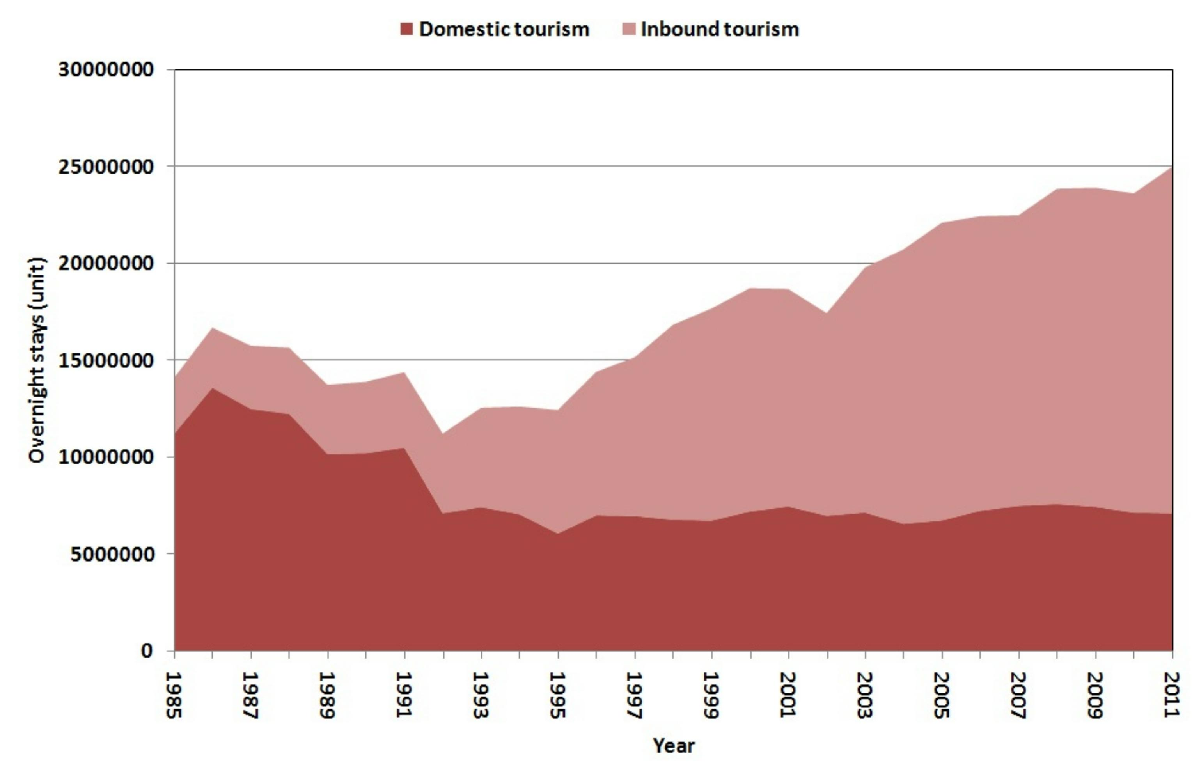
FIGURE 1: Total annual overnight stays of domestic and inbound tourists in Cuba over the period 1985 to 2011.

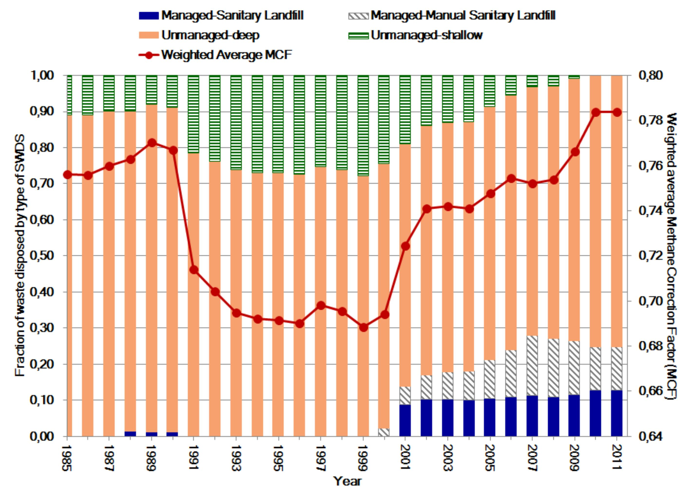
FIGURE 2: Proportion of DTSW and ITSW disposed annually by types of SWDS and annual weighted average MCF calculated at country-level in Cuba over the period 1985 to 2011.

TABLE 2: Physical composition of DTSW and ITSW generated in AF and NHSF used in the study (%).
Waste component | AF | NHSF
Food waste | 55 | 40
Paper and cardboard | 13 | 19
Textile | 2 | 2
Wood and straw | 2 | 2
Garden and park waste | 10 | DU
Plastic | 5 | 6
Glass | 4 | 7
Metal | 2 | 9
Others | 7 | 15
DU – Data unavailable.

Considering that available waste composition statistics refer to the composition of wastes generated, in order to estimate the quantity and composition of ITSW and DTSW going annually to SWDS, annual figures of DTSW and ITSW generated at country level, for each waste component, were adjusted to take into account the impact of recycling that was practically the only treatment applied. Other treatments had an insignificant effect in the assessed period.

In the estimation the percentages of recyclables recovered by waste component in Havana as tourist destination provided in Joa & Falcon (2008) and the fractions of overnight stays for domestic and inbound tourists, were used to estimate annually the recycled quantities by waste component associated to ITSW and DTSW. Annual recycling figures grew from 1.5% to around 5% of generated solid waste in the period assessed. To estimate the annual quantity and composition of DTSW and ITSW disposed in SWDS, the recycled quantities of ITSW and DTSW were subtracted from the figures of annual DTSW and ITSW generated for each waste component.

Model used to estimate methane emissions from solid waste disposal

Methane is emitted during the anaerobic microbial decomposition of organic matter disposed in solid waste disposal sites (SWDS). The method selected for the estimation of CH₄ emissions, is the IPCC Waste Model provided in IPCC (2006) and based on the First Order Decomposition (FOD). The multiphase option of the model was applied using mostly default emission parameters from the IPCC (2006), specified detailed in López, 2011 (Table 3) and country-specific data.

Activity data necessary to perform the estimate consist of the waste generation by waste component, and the fraction of waste generated that was disposed to SWDS in each year of the period assessed. In the FOD method, to achieve accurate emission estimates, it’s usually necessary to include data on solid waste disposal (amount and composition) for 3 to 5 half-lives of the waste deposited at the SWDS (IPCC, 2006). In the estimation were used the available annual data gathered for the study, twenty six years of data from 1985 to 2011. Although that quantity of years is something smaller than recommended in IPCC (2006), given the moist and wet tropical conditions in Cuba this period does represent three half-lives for the main degrading components. Furthermore the period includes the stage tourism growth (mainly inbound) in Cuba that began around 1992 as was shown in Figure 1.

TABLE 3: Activity data and emission parameters used in the estimation of CH₄ emissions from DTSW and ITSW disposed in SWDS. FOD Method.
Activity data and  Emission Parameter |  | Value | Uncertainty Range | Comments
Total solid waste (Gg) |  | - | ±30% | Data summarized in Figure 3
Waste composition |  | - | ±50% | Calculated from data provided in Table 2
MCF | Methane correction factor (fraction) for aerobic decomposition in the year of solid waste disposal (fraction) | 1.0ª | -10%, +0% | Managed - anaerobic. Sanitary landfill^{d}
MCF |  | 0.5^{b} | ±20% | Managed - anaerobic. Manual sanitary landfill with towers for evacuation of gases.
MCF |  | 0.4^{b} | ±30% | Managed - anaerobic. Manual sanitary landfill without towers for evacuation of gases
MCF |  | 0.8ª | ±20% | Unmanaged - deep
MCF |  | 0.4ª | ±30% | Unmanaged - shallow
DOC | Fraction of degradable organic carbon in solid waste (Gg C Gg SW⁻¹) | ⁻ | ±20% | Calculated using data provided in Table 2 and default DOC content for MSW components provided in 2006 IPCC Guidelines
DOC_{F} | Fraction of DOC that can decompose (fraction) | 0.5ª | ±20% | -
F | Fraction by volume of CH₄ in generated landfill gas | 0.5ª | ±5% | -
OX | Oxidation factor (fraction). Reflects the amount of CH₄ from SWDS that is oxidized in the soil or other material covering the waste | 0ª | - | Managed (not covered with aerated material) and unmanaged SWDS
OX |  | 0.1ª | 0.05-0.15 | Managed covered with oxidizing material (compost, soil). Sanitary landfills
OX |  | 0.2^{b} | 0.1-0.26 | Managed covered with oxidizing material (soil). Manual sanitary landfills
k | Methane generation rate (1yr⁻¹). Tropical (moist and wet) conditions
 | Paper/cardboard and textiles | 0.07ª | 0.06-0.085 | Slowly degrading waste
 | Wood and straw | 0.035ª | 0.03-0.05 | Slowly degrading waste
 | Rubber and leather | 0.02^{b} | 0.015-0.025 | Slowly degrading waste
 | Other (non-food) organic putrescible/Garden and park waste | 0.13^{c} | 0.11-0.15 | Moderately degrading pruning waste
 | Food waste/Sewage sludge | 0.4ª | 0.17-0.7 | Rapidly degrading waste
DT | Delay time (months) | 6 | - | -
R | Recovered CH₄ per year (Ggyr⁻¹) | 0 | - | Recovered CH₄ in SWDS was cero from 1985-2008 and insignificant since 2009 to 2011.
a) IPCC default value (IPCC 2006); b) Country – specific value (López 2011); c) SCS Engineers (2009). Additionally in this study a part of pruning wastes was considered as moderately degrading waste and other part as rapidly degrading waste (López, 2011). d) In part of assessed period was used a MCF = 0.8 for this type of SWDS. Gg – gigagrams = 1 kiloton; yr – year

Sensitivity analysis and uncertainty quantification

According to IPCC (2006) ‘the best way of evaluating the error due to the FOD model is performing a sensitivity analysis (SA) or a Monte Carlo analysis’. In this study SA and uncertainty quantification for aggregated DTSW and ITSW from AF and NHSF were performed together for all the model inputs (emission parameters and activity data) with its uncertainty and error ranges provided in Table 3. Emission parameters included in the analysis were K (CH₄ generation rate), DOC (degradable organic carbon), DOC_{f} (fraction of DOC that decomposed), MCF (methane correction factor), F (fraction of CH₄ in generated landfill gas) and OX (oxidation factor). DOC was estimated from DTSW and ITSW composition data and default DOC content by waste component.

In the analysis, minimum, average and maximum values of the ranges of each model input considered were used to compare three tests cases, Low (L), Baseline (B) and High (H) (Pannel, 1997). Results were obtained by varying alternately one input parameter and keeping others in their baseline values and repeating for each of the other inputs (U. S. EPA, 1997). Also was taking into account simultaneous variation of the input variables activity data (AD), DOC_{f} and DOC that, ordered by importance, were identified in the SA as the inputs that influence more on the overall uncertainty and variation in the model’s outputs. They were selected because caused the biggest emission differences with the baseline case (≥ 20%) and had high values of the sensitivity index (Hofmand & Garden, 1983) and elasticity (Pannel, 1997). With the model were assessed for each parameter’s combinations AD-DOC; AD-DOC; DOC_{f}-DOC the following cases: Low-Low, Low-High, High-Low, High-High.

Methane emissions calculated for 2011, from all the cases assessed (n = 50, 25 both for DTSW and ITSW) as alternatives of the model output, produced the results used to perform the quantitative uncertainty analysis by estimating the 95 percent confidence interval of the emissions estimates. Data management and statistical analysis were performed with the WinIDAMS software (UNESCO 2004) and Excel. Normal distribution of the outputs obtained with the model was tested using the Shapiro-Wilk (W) test (Shapiro & Wilk 1965), the Anderson-Darling test (Anderson & Darling 1954) and the Lilliefors (K-S) LD test (Lilliefors 1997). The results obtained in these tests (W = 0.968 > CV_{0.05}, A2 = 0.279 < CV_{0.05} and LD = 0.071 ˂ CV_{0.05}) confirmed that the null hypothesis of normality for the CH₄ emission data is not rejected. Then, was estimated a symmetrical 95% confident interval expressed as a percentage (±50.9%).

Results and discussion

Domestic and inbound tourism solid waste generation and disposal in Cuba
Figure 3 summarizes domestic and inbound tourism solid waste generation both in AF and NHSF in Cuba from 1985 to 2011. As can be observed, there has been a trend toward the decrease in DTSW generation (20.38 Gg in 1985 and 14.51 Gg in 2011). Conversely ITSW generation in Cuba increased notably between these years from 7.82 Gg yr⁻¹ to 69.29 Gg yr⁻¹, consistent with the significant growth in annual inbound tourists and overnight stays of inbound tourists that occurred over this period. In 2011 AF and NHSF generated 67% and 33% of DTSW respectively. Regarding ITSW, AF and NHSF generated 71.2% and 28.8% in that order

In Cuba, almost all of DTSW and ITSW generated in AF and NHSF still goes to landfills. The fraction of DTSW and ITSW generated that was disposed in SWDS was around 0.98 to 0.95 over the period assessed. Those fractions were used to estimate the solid wastes derived from the tourism that were disposed annually in SWDS.

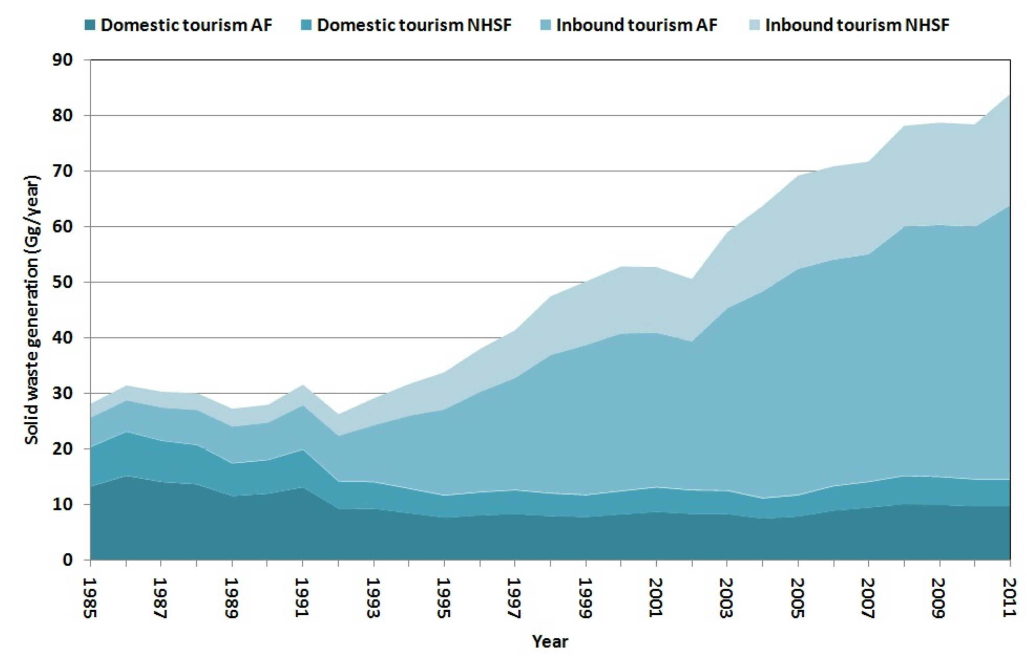
FIGURE 3. Generation of domestic and inbound tourism solid waste in accommodation facilities and non-hotel services facilities of Cuba over the period 1985 to 2011 (Gg).

Methane emissions from domestic and inbound tourism solid waste disposal

Figure 4 shows the annual net CH₄ emissions in 2011 arising from DTSW and ITSW landfilled in Cuba from 1985 to 2011. In that year these emissions amounted to 0.92-2.82 Gg CH₄ yr⁻¹ with 1.87 Gg yr⁻¹, as the most likely value (0.40 Gg CH₄ yr⁻¹ derived from domestic tourism and 1.47 Gg CH₄ yr⁻¹ from inbound tourism). Seventy-two per cent of these emissions were attributable to AF and 28% to NHSF. Regarding AF categories, for inbound tourism, ‘hotels 4 Stars’ had the biggest contribution to those emissions while for domestic tourism the biggest emissions occurred in the category ‘Other AF’. This last category includes the camping bases where domestic tourism had the biggest annual quantity of overnight stays.

For comparison, the estimation of CH₄ emissions associated to MSW disposal in Cuba from 1950 to 2010 performed in López (2011), was extended up to 2011 but considering the same period used for DTSW and ITSW (1985-2011). In this former assessment, total national CH₄ emission in 2011 from MSW disposal resulted 43.8 Gg CH₄ (excluding ITSW) and 45.3 Gg CH₄ (including ITSW), around 3.4% of difference.

Table 4 presents per-capita CH₄ emissions from DTSW and ITSW for 2011 in Cuba. Per-capita CH₄ emissions from DTSW in 2011 was 0.052 kg CH₄ domestic tourist⁻¹ day⁻¹ (0.035 kg from AF and 0.017 kg from NHSF). The biggest per-capita emissions were observed in hotels 4 Stars and 3 Stars. In regard to inbound tourism, per-capita CH₄ emissions from ITSW in 2011 was 0.084 kg CH₄ inbound tourist⁻¹ day⁻¹ (0.062 kg from AF and 0.022 kg from NHSF) and the biggest per-capita emissions occurred in hotels 5 Stars and 4 Stars. Both domestic and inbound tourism per-capita CH₄ emissions from solid waste disposal resulted higher than per-capita emissions related to MSW disposal from urban local residents in Cuba (0.014 kg CH₄ capita⁻¹ day⁻¹) reported in López (2011). This may be explained by the biggest tourist’s per-capita solid waste generation rate.

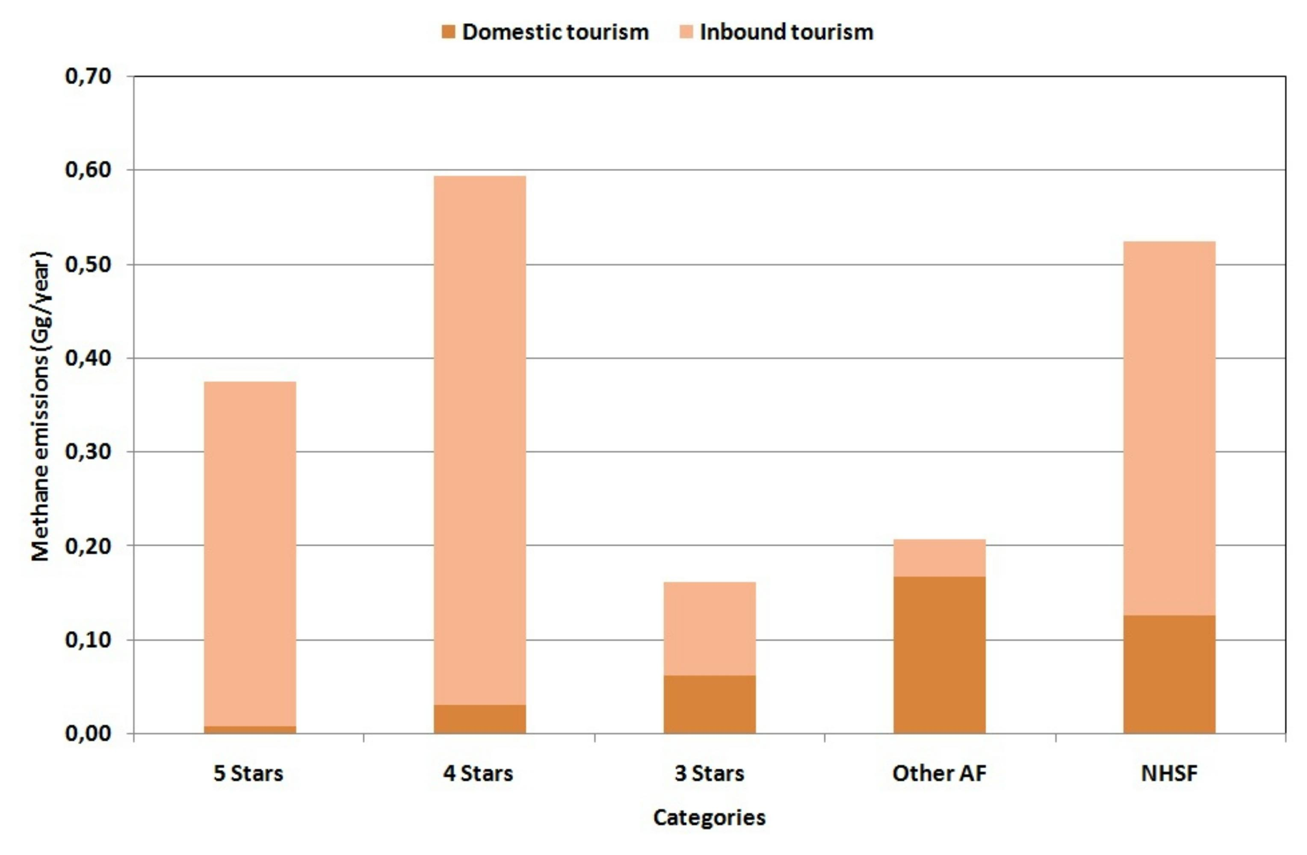
FIGURE 4: Net CH₄ emissions in 2011 by AF categories and NHSF derived from DTSW and ITSW disposed in SWDS in Cuba since 1985 to 2011 (Gg yr⁻¹).

TABLE 4: Per - capita CH₄ emissions from DTSW and ITSW for 2011 in Cuba.
Domestic Tourism (kg CH₄/domestic tourist/day)
DTSW (total) | AF (total) | Hotels  5 Stars | Hotels 4 Stars | Hotels 3 Stars | Other AF | NHSF
0.052 | 0.035 | 0.040 | 0.060 | 0.056 | 0.029 | 0.017
Inbound Tourism (kg CH₄/inbound tourist/day)
ITSW  (total) | AF (total) | Hotels  5 stars | Hotels 4 stars | Hotels 3 stars | Other AF | NHSF
0.084 | 0.062 | 0.065 | 0.060 | 0.053 | 0.033 | 0.022
AF- Accommodation facilities, NHSF – Non-hotel services facilities

Accounting and reporting issues related to methane emissions from MSW and ITSW generation and disposal

Underestimation or overestimation of national CH₄ emissions derived from MSW landfilled could occur as consequence of the method used in the NGHGI to estimate the amount of MSW disposed annually in SWDS and the inclusion, or not, of ITSW in that amount. In this paper was assessed the possible significance of this underestimation or overestimation with regard the country of reference (Cuba in this case study).

The MSW disposed in SWDS is estimated using one of three main methods: I. Annual per-capita MSW generation rates, annual population figures, and annual disposal fractions; II. Waste delivery vehicles capacity and known values of waste density or visual estimations; III. Scales, to weigh the solid wastes entering SWDS. In developed countries method III is normally applied while in developing countries, due to limitations of resources, methods I and II are more usual.

In the method I, to obtain the total MSW generation in the country, the per-capita values should be multiplied by the population whose waste is collected. In many countries, especially developing countries, this encompasses only urban population (IPCC, 2006). Both the use of resident population's data and per-capita generation values associated to this without considering the inbound tourist's contribution to the generation of waste, as in the NGHGI of Cuba, underestimate the CH₄ emissions.

Table 5 summarizes the effects on estimation of CH₄ emissions from MSW disposal, caused by the use of methods I, II, III described above in the NGHGI of Cuba (tourism receptor country in this case study) and the NGHGI of countries emitters of tourism to Cuba.

According to the results obtained in the assessment performed, the non-inclusion of ITSW in the estimates of MSW generated and landfilled in Cuba caused a small underestimation of about 3.4 per cent in the CH₄ emissions from this source category in 2011 though. That percentage could continue increasing in correspondence to the foreseen tourism growth in the Country and if are not implemented appropriate mitigation measures, including the reduction of the amount of solid wastes generated in AF and NHSF and disposed in SWDS, and the increment of the CH₄ capture in those sites and either used with energy recovery or flared. Also, it is considered that the former small underestimation could be greater in the GHG inventories of tourism receptor countries with a bigger proportion inbound tourists/resident population, in comparison with Cuba.

TABLE 5: Effects on estimation and reporting CH₄ emissions from ITSW disposal of in SWDS derived from the method used in the NGHGI to estimate the quantity MSW generated and disposed and the inclusion, or not, of ITSW.
 | Method Used in the NGHGI |  | CH₄ Emissions from ITSW disposal of in SWDS
 | TRC | TEC | TRC | TEC | Comments
a | I | I | N | In | Subestimation in the TRC and overestimation¹ in the TEC
b | I | II or III | N | N | Subestimation in the TRC and correct estimation in the TEC
c | II or III | I | In | In | Estimation performed in both countries. Correct estimation in the TRC and overestimation¹ in the TEC.
d | II or III | II or III | In | N | Correct estimation both in TRC and TEC
- The ITSW generated by those people are included in the TEC, but really were generated and disposed in the TRC. This overestimation is insignificant in the tourism emitter countries and it doesn't require to be considered in the corresponding NGHGI.
TRC – Tourism receptor country, TEC – Tourism emitter country, N – Not included; In – Included

Conclusions

The results revealed that in Cuba over the period assessed (1985-2011), domestic tourism solid waste generation had a general trend toward the decrease (20.38 Gg in 1985 and 14.51 Gg in 2011). Conversely, inbound tourism solid waste generation increased notably between these years (from 7.82 Gg yr⁻¹ to 69.29 Gg yr⁻¹) consistent with the significant growth in annual inbound tourists and overnight stays of inbound tourists that occurred over this period.

According to the findings obtained most of solid waste generation is attributed to AF. In 2011 AF and NHSF generated 67% and 33% of domestic tourism solid waste respectively and regarding inbound tourism solid waste, AF and NHSF generated 71.2% and 28.8% in that order. The fraction of DTSW and ITSW generated that was disposed in SWDS was around 0.98 to 0.95 over the period assessed.

The model estimated that in 2011 net CH₄ emissions derived from domestic and inbound tourism solid waste disposed in SWDS in Cuba from 1985 to 2011 amounted to 0.92-2.82 Gg CH₄ yr⁻¹ with 1.87 Gg yr⁻¹, as the most likely value (0.40 Gg CH₄ yr⁻¹ derived from domestic tourism and 1.47 Gg CH₄ yr⁻¹ from inbound tourism).

In correspondence with the figures of waste generation, 72% of the CH₄ emissions estimated for 2011 were attributable to AF and 28% to NHSF. Regarding AF categories, for inbound tourism, ‘hotels 4 Stars’ had the biggest contribution to those emissions while for domestic tourism the biggest emissions occurred in the category ‘Other AF’. This last category includes the camping bases where domestic tourism had the biggest annual quantity of overnight stays.

Per-capita CH₄ emissions from domestic tourism solid waste in 2011 was 0.052 kg CH₄ domestic tourist⁻¹ day⁻¹ (0.035 kg from AF and 0.017 kg from NHSF). Major per-capita emissions were observed in hotels 4 Stars and 3 Stars. In regard to inbound tourism, per-capita CH₄ emissions from inbound tourism solid waste in 2011 was 0.084 kg CH₄ inbound tourist⁻¹ day⁻¹ (0.062 kg from AF and 0.022 kg from NHSF) and the biggest per-capita emissions occurred in hotels 5 Stars and 4 Stars. Both domestic and inbound tourism per-capita CH₄ emissions in 2011 from solid waste disposal resulted higher than per-capita emissions from MSW disposal from urban local residents in the Country in that year (0.014 kg CH₄ capita⁻¹day⁻¹).This may be explained by the biggest tourist’s per-capita solid waste generation rate.

The results indicate that per-capita models can underestimate CH₄ emissions from MSW landfilled estimated in national GHG inventories of countries with significant inbound tourism. The non-inclusion of ITSW in the estimates of MSW generated and landfilled caused a small underestimation of about 3.4 per cent in the CH₄ emissions in 2011 derived from MSW disposal in SWDS in Cuba though that percentage could continue increasing in correspondence to the foreseen tourism growth in the Country and if in the future are not implemented appropriate mitigation measures. The research suggests that the former underestimation could be greater in the GHG inventories of tourism receptor countries, with a bigger proportion inbound tourists/resident population, in comparison with Cuba.

The results of this study can also contribute to improve the estimation of tourist’s carbon footprint frequently incomplete and only centred in the emissions originated from the energy consumption.

Acknowledgments
The author would like to thank C. Terry and U. Acosta for sharing information on solid waste generation and composition in accommodation facilities of several tourist destinations of Cuba and recuperation of recyclables in Havana as tourist destination respectively.

References

Anderson, T.W. & Darling, D.A. (1954) A Test of Goodness-of-Fit. Journal of the American
Statistical Association 49: 765–769

Aguilera - Corrales, Y., Korner, I., & Saborit, I. (2005) Solid waste management in Cuba under
special consideration of composting. Proceedings Tenth International Waste Management
and Landfill Symposium. Cagliari, Italy; 3-7 October, 2005, 9 pp.
http://www.docstoc.com/docs/29652568/Solid-Waste-Management-In-Cuba-Under-Special-Consideration-Of# (May 18, 2012).

Ahmad, P. & G. A. Bhat (2008) Indiscriminate Disposal of Solid Waste Choking World Famous
Dal Lake in Kashmir Valley. Proceedings of Taal2007: The 12th World Lake Conference:
1458-1462 http://wldb.ilec.or.jp/data/ilec/wlc12/P%20-%20World%20Case%20Studies/P-18.pdf
(September 25, 2012)

Becken, S. & M. Patterson (2006) Measuring National Carbon Dioxide Emissions from Tourism
as a Key Step Towards Achieving Sustainable Tourism. Journal of Sustainable Tourism,
Volume 14, Issue 4, 2006, pages 323-338

Bogner, J., Pipatti, R., Hashimoto, S., Diaz, C., Mareckova, K., Diaz, L., Kjeldsen, P., Monni, S.
& Faaij, A. (2008) Mitigation of global greenhouse gas emissions from waste: conclusions
and strategies from the IPCC Fourth Assessment Report. Working Group III (Mitigation).
Waste Management & Research, 26, 11–32

Brown, K., R. K. Turner, H. Hameed & I. Bateman (1997) Environmental carrying capacity and
tourism development in the Maldives and Nepal. Environmental Conservation, Volume 24,
Issue 04, December 1997, pp 316-325

Cusman, R. M. & S. B. Jones (2002) The Relative Importance of Sources of Greenhouse-Gas
Emissions: Comparison of Global Through Sub national Perspectives. Environmental Management, March 2002, Volume 29, Issue 3, pp 360-372

Gutiérrez Palacios, C. (2002) Estrategias para el manejo integral de los residuos sólidos en
centros turísticos. XXVIII Congreso Interamericano de Ingeniería Sanitaria y Ambiental Cancún, 27 al 31 de octubre, 2002, 8 pp.
http://bases.birene.br/cgi/bin/wxislind.exe/ish/online/?IsisScript=iah.xis&src=google&base=REPDISVA&long=p&nextAction=Ink&expSearch=6275&indexSearch=10 (July 25, 2012)

Hockett, D., Lober, D. J., & Duke, K. P. (1995) Determinants of per-capita municipal solid waste
generation in the south eastern United States. Journal of Environmental Management, 45, 205–217

Hoornweg, D. & N. Giannelli (2007) Managing municipal solid waste in Latin America and the
Caribbean. PPIAF, Gridlines, Note No. 28 – Oct. 2007, 4pp. www.ppiaf.org/gridlines (July 20, 2012)

IPCC (2006). 2006 IPCC Guidelines for National Greenhouse Gas Inventories. Prepared by
the NGHGIP, Eggleston H. S., Buendia L., Miwa, K., Ngara T., and Tanabe, K. (eds). Published: IGES, Japan.

Joa, J. M., & Falcón C. A. (2008) Estudio de la Situación de la Recogida de Materias Primas
en el Polo Turístico de Ciudad de La Habana, EISD, MINBAS, La Habana, Cuba, 157pp.

Konan, D. E., H. L. Chan (2010) Greenhouse gas emissions in Hawaii: Household and visitor expenditure analysis. Energy Economics, Volume 32, Issue 1, January 2010, Pages 2010-219

Kuo, Nae-Wen & Pei-Hun Chen (2009) Quantifying energy use, carbon dioxide emission, and
other environmental loads from island tourism based on a LCA approach.
Journal of Cleaner Production, Volume 17, Issue 15, October 2009, Pages 1324–1330

Lilliefors, H. W. (1967). On the Kolmogorov-Smirnov test for normality with mean and variance
Unknown. Journal of the American Statistical Association, 62, 399–402

López, C. (2011) Escenarios combinados de gestión ambiental-mitigación para la proyección
de las emisiones de metano derivadas de los desechos sólidos municipales en Cuba,
GHGC, La Habana, Cuba, 132pp.
http://ncsp.undp.org/sites/default/files/C%20Lopez%20_2011_Escenarios%20Combinados%20de%20Gestión%20Ambiental%20-%20Mitigación.pdf (October 20, 2012)

Nipon (2004) Estudio de Plan Maestro sobre Manejo Integral de los Residuos Sólidos Urbanos
en la Ciudad de La Habana. Informe de Avance (1). Vol. 1 and Vol. 2. Nipon Koei Co., Ltd. Pacific Consultants International, La Habana.

ONEI (2012) Series Estadísticas. Oficina Nacional de Estadísticas e Información. La Habana,
http://www.one.cu (June 10, 2012)

Palacios, F., García, E., & Ruiz, F. (2002) Gestión ambiental y manejo integrado de residuos sólidos en Tarará, XVIII Congreso Interamericano de Ingeniería Sanitaria y Ambiental,
Cancún, 27 al 31 de octubre, 2002, 8pp
http://www.bvsde.paho.org/bvsaidis/mexico26/iv-060.pdf (August 25, 2012)

Pannell, D.J. (1997) Sensitivity analysis of normative economic models: Theoretical framework
and practical strategies, Agricultural Economics, 16: 139-152.

Phuong Chi, H. (2005) Audit of solid wastes from hotels and composting trial in Halong City,
Vietnam, 94 pp. DCE, University of Toronto, Canada:
http://www.utoronto.ca/waste-econ/HoangPhuongChi.pdf (January 25, 2012)

Proenza L. A. (2010) Procedimiento específico para el tratamiento de los residuos sólidos
generados en el hotel Gran Hotel, Universidad de Camagüey, Cuba, 142pp.
http://www.repositorio.ehtc.cu/jspui/bitstream/ehtc/91/1/Procedimiento Especifico para el Tratamiento de los Residuos Sólidos Generados en el Hotel Gran Hotel.pdf (April 17, 2012)

SEMARNAT (2004) Diagnóstico Ambiental del Sector Hotelero en la República Dominicana,

Secretaría de Estado de Medio Ambiente y Recursos Naturales. Santo Domingo, 29pp.

Shamshiry, E., Nadi, B., Bin Mokhtar, M., Komoo, I., Saadiah Hashim, H., & Yahaya, N. (2011)

Integrated models for solid waste management in tourism regions: Langkawi Island, Malaysia. Journal of Environmental and Public Health, Volume 2011.

Singh, N., D. A. Cranage, A. Nath (2013) Estimation of GHG emission from hotel industry. Anatolia – An International Journal of Tourism Research. Published online: 05 Sep 2013

Shapiro, S. S. & Wilk, M. B. (1965) An analysis of variance test for normality (complete
samples). Biometrika, 52, 591-611

Simpson, M.C., Gössling, S., Scott, D., Hall, C.M. and Gladin, E. (2008) Climate Change
Adaptation and Mitigation in the Tourism Sector: Frameworks, Tools and Practices. UNEP,
University of Oxford, UNWTO, WMO: Paris, France, 152 pp.

SCS Engineers (2009) Manual de usuario Modelo Mexicano de Biogás versión 2.0.

http://www.epa.gov/lmop/documents/pdfs/manual_del_usuario_modelo_mexicano_de_biogas_v2_2009.pdf (July 20, 2012)

Tang, J. (2004) A case study of hotel solid waste management program in Bali, Indonesia, 189

pp. University of Waterloo, Ontario, Canada.

http://www.collectionscanada.gc.ca/obj/s4/f2/dsk3/OWTU/TC-OWTU-373.pdf (August 26,

2012)

Terry, C. (2012) Personal communication with C. Terry, specialist from the Information, and
Environmental Education Center. Environment Agency of Cuba.

Trung, D.N., & Kumar, S. (2005) Resource use and waste management in Vietnam hotel

industry. Journal of Cleaner Production, 13, 109–116

UNWTO (2008) Understanding tourism: Basic glossary. United Nations World Tourism

Organization, Madrid, Spain:

http://media.unwto.org/en/content/understanding-tourism-basic-glossary (June 25, 2012)

UNESCO (2004) IDAMS. Internationally Developed Data Analysis and Management Software
Package Release 1.2, Paris, France.
UNWTO - UNEP - WMO (2008). Climate Change and Tourism: Responding to Global
Challenges, (prepared by Scott, D., Amelung, B., Becken, S., Ceron, JP., Dubois, G.,
Gössling, S., Peeters, P. and Simpson, M.C.), UNWTO, Madrid, and UNEP, Paris, 24 pp.

U. S. AID (1999) Solid Waste Audit of Hotels in Dominica, St. Lucia, and the Dominican
Republic, EHP Activity Report No. 68, June 1999, 82 pp.

http://pdf.usaid.gov/pdf_docs/PNACG408.pdf (September 26, 2012)

U. S. EPA (1997) Emission Inventory Improvement Project (EIIP), Volume VI: Chapter 3.

General QA/QC Methods, U. S. Environmental Protection Agency, Washington, DC, U.S.A.,

June 1997, 154 pp.

